**PRACTICAL - 3**

**AIM:** Demonstrate the static routing configuration between 3 routers using cisco packet tracer

**THEORY:**

**ROUNTING - Routing is the process of selecting a path for traffic in a network or between or across multiple networks. Broadly, routing is performed in many types of networks, including circuit-switched networks, such as the public switched telephone network (PSTN), and computer networks, such as the Internet.**

**Static routing is a form of routing that occurs when a router uses a manually-configured routing entry, rather than information from a dynamic routing traffic.**

**Advantages of Static Routing**

* **Static routing causes very little load on the CPU of the router, and produces no traffic to other routers.**
* **It is useful where numbers of route are limited.**
* **Static routing leaves the network administrator with full control over the routing behaviour of the network.**
* **Static routing is the most secure way of routing.**
* **It reduces overhead from network resources.**
* **It is easy to implement.**

**Disadvantages of Static Routing**

* **It is suitable only for small network.**
* **If a link fails it cannot reroute the traffic.**

**TOPOLOGY:**

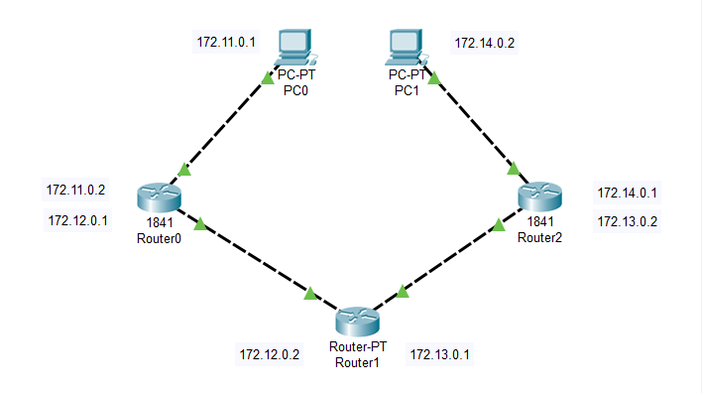

**Provide IP address to all the PC connected in LAN**

1. **Click on PC, go to Desktop tab in that IP Configuration option**
2. **Provide IP address and Default Subnet mask**
3. **Provide IP Address to both PC as 172.11.0.1 and 172.14.0.2 respectively**

**NOTE - In default gateway add IP address of Router’s Fast Ethernet IP, to which PC is connected with.**

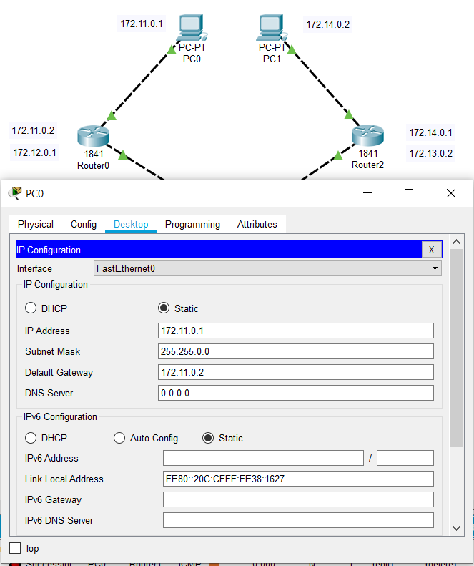

**STEPS OF CONFIGURATION**

**Provide IP address to all the Routers**

1. **Click on each router.**
2. **Each connection should be treated as different network, having these on your mind assign IP to all routers.**
3. **Don’t forget to turn on the port status in router after configuring it.**

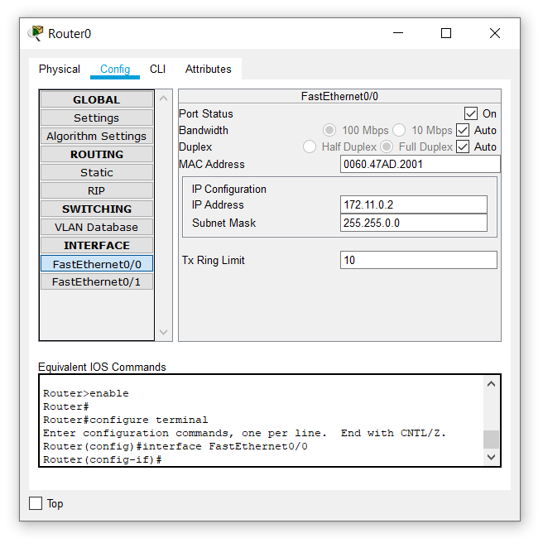

**Provide Static Routes to Routers**

**By default, router knows only about those networks which are directly connected to it.**

**So, next step is to provide information of all the networks and the next hop to reach those networks. To create static routing table:**

1. **Click on each router and go to Config and then in Static.**
2. **In Network, add the IP of Network which is not connected directly.**
3. **Add Default Subnet Mask**
4. **Add the IP of Network in Next Hop through which it makes aa connection between two directly non-connected networks.**

**For example, Next Hop for Connection between Router 0 and 172.13.0.0 will be 172.12.0.2**



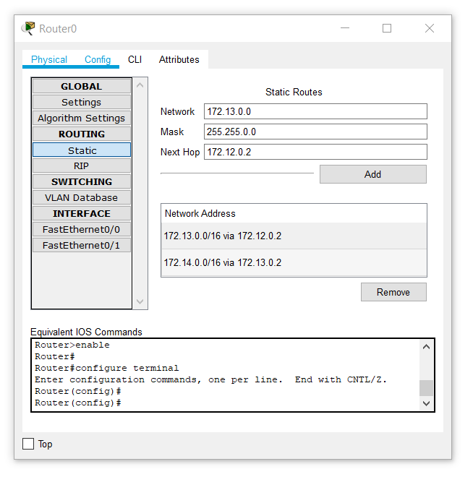

**CHECK NETWORK TOPOLOG**

We can check if the connection is working properly by two ways:

1. **DROPPING A PACKET**

First check static routing by dropping packets from PC0 to different Routers

Then, Drop a message from PC0 to PC1

**Note***:* If Status is Successful in transferring message means your static routing connection is perfect and if status is failed means there is some problem in PC or State Routing configuration.

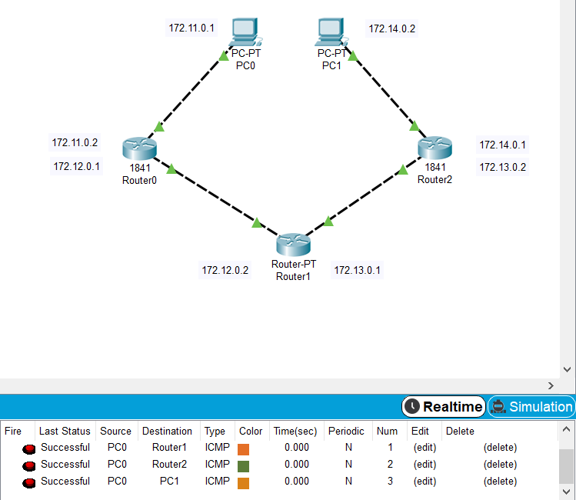



1. CHECKING NETWORK TOPOLOGY USING **PING** COMMAND

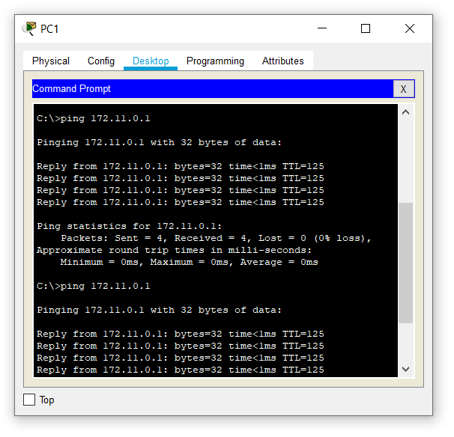

**CONCLUSION:**

From this practical, we are able to understand what is static routing and how to configure that in router. We also learn the advantages and disadvantages of static routing.